Cardiﬀ Ageing Well Strategy

2022 - 2027

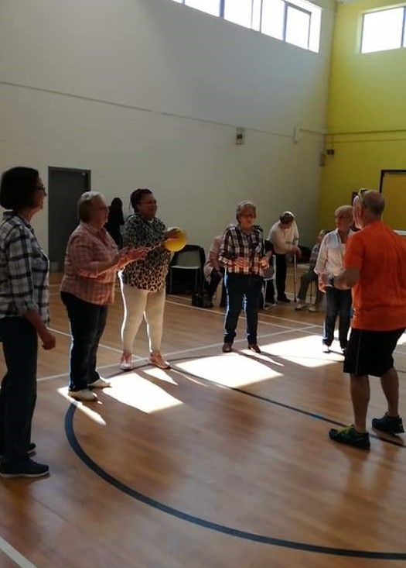
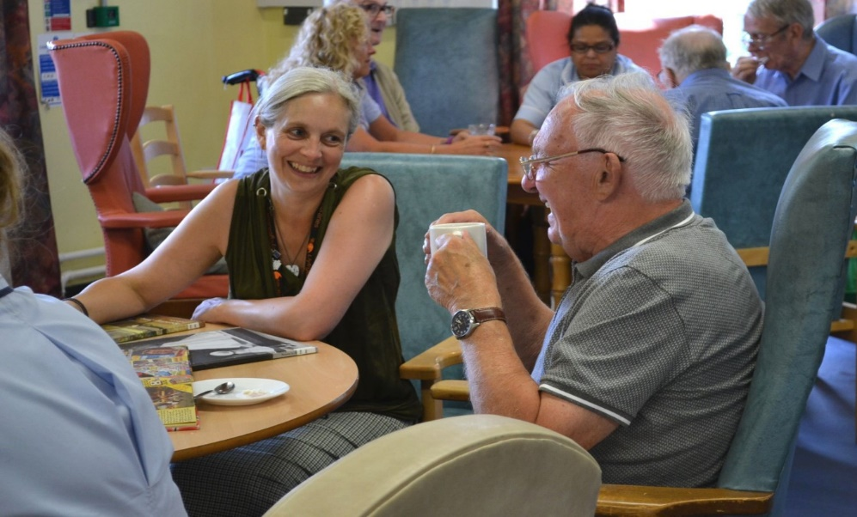

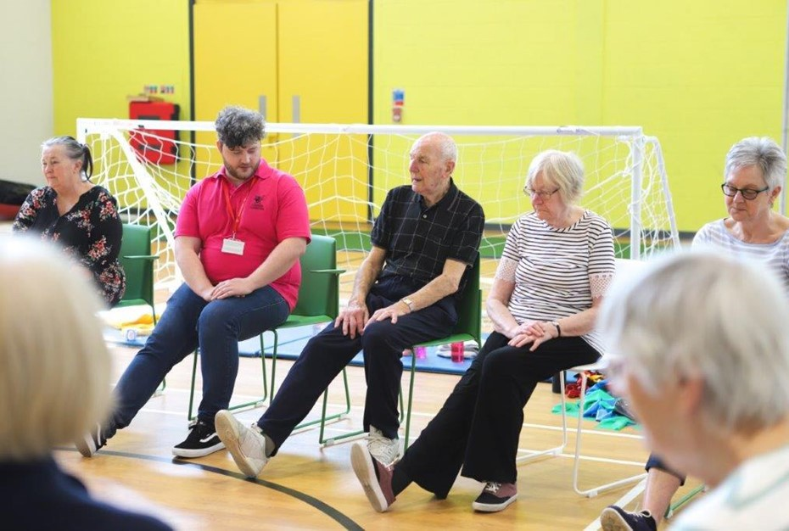




Content Page

Foreword 3

Overview of Cardiﬀ health needs 4

Background 5

Strategic Background 6

Consultation 7

Vision, Principles & Key Aims 8

Supporting older people to stay active and connected in an age friendly 9

city

Supporting older people to live independently at home through 14

strengths based preventative services

Working in partnership to deliver high quality sustainable care and 25

support

Supporting informal carers and valuing their role 30

Ensuring our services meet the needs of the most vulnerable 31

Proactively modernising our services 33

Equality & Diversity 34

Implementing, Monitoring & Review 36

2


Councillor Susan Elsmore

Cabinet Member for Social Care, Health and Well-being

I am delighted to present Cardiﬀ Council’s Ageing Well Strategy.
Never is there a more important time to look to the future, and to consider how we can best
support older people to live healthy, fulﬁlled lives within their communities.
Listening to the voice of individuals is at the heart of the strategy: our services should empower older people to live life as they choose, providing the right support at the right time to help people retain their independence and achieve their chosen outcomes.
The pandemic continues to place massive pressures on the health and social care system. More recently the surge in demand that followed lockdown is testing the system to the limit, highlighting a pressing need for change. We are committed to working with Welsh Government to take this work forward.
Never has it been clearer how important the partnerships are between the Council, Health Board, the third sector and independent care providers. The pandemic has brought us closer together and encouraged new ways of working. As the Cabinet Member and the Chair of the Regional Partnerships Board’s Ageing Well Partnership, I want to take this learning into the future as we develop truly person-centred and joined up services. This strategy sets out how Cardiﬀ Council will play its part in enabling its citizens to age well.
Finally, I want to take the opportunity to praise and express my gratitude to the social care workforce, who have continued to provide services in the most challenging circumstances.
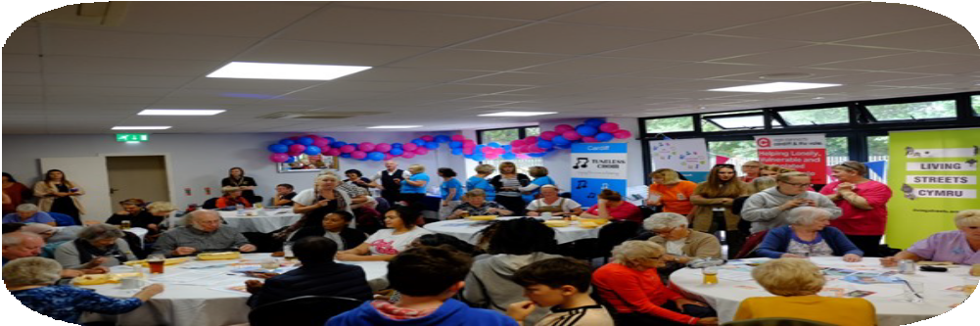
My thanks also go to carers, both paid and unpaid, who have provided essential care to our most vulnerable citizens throughout the pandemic.

Cllr. Susan Elsmore

3

The health needs of the city are changing as the population ages. Covid-19 has also impacted on the health of our citizens as has been seen in the emerging ﬁndings of the Cardiﬀ and Vale of Glamorgan Population Needs Assessment. As needs change so will the demand for services.

Current Health Needs

Emerging Findings from Population


Needs Assessment
Male Life
Expectancy
78
Female Life
Expectancy
83

The Cardiﬀ and Vale of Glamorgan Population Needs Assessment is currently being ﬁnalised. However, the draft document highlighted the following:
Around One in Ten
adults provide informal care

- Mobility and circulatory conditions of older people have deteriorated due to Covid-19 lockdowns. Deteriorating mobility heightens the risk of a fall.
One in Ten adults have
hearing loss

- Loneliness and isolation has increased. Some who were self- suﬃcient are now in need of support due to reduced resilience.
There are 132 hospital
admissions annually due to a fall

- The digital divide has increased with more services moving to online only.
There are 3,819 people with
dementia. Two Thirds have
severe dementia
- Alzheimers and dementia were the most common pre-existing conditions for people who died from Covid-19.
20% of the
population have a mental health
diﬃculty



4
Unless stated otherwise all data is for 2021. Data taken from Stats Wales and Daﬀodil

An Ageing Population
The population in Cardiﬀ is ageing, as it is across Wales. The increase in life expectancy is a positive change, and older people clearly contribute positively to their local communities in many ways, including through paid and unpaid work and by caring for others.
However, the number of older people with life limiting conditions and in particular living with dementia is also increasing. This could potentially result in a signiﬁcant increase in demand for services.
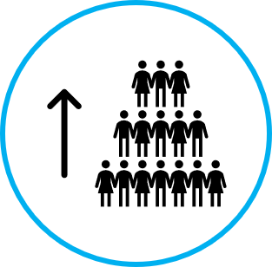
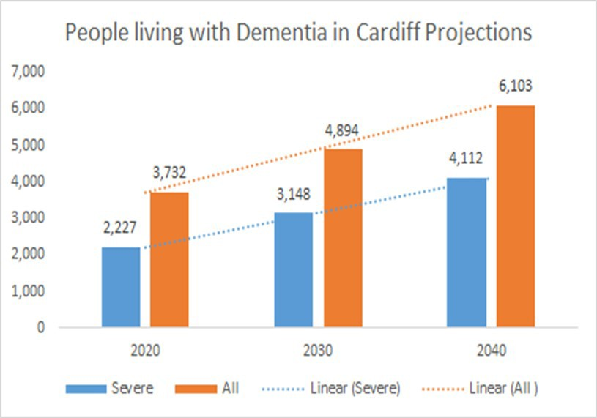

Projected Ten Year Population Increase
17.8 % increase age 65+
9.2 % increase age 85+
5.9 % increase age 90+
The number that struggle with activities of daily living will increase by 17% in 2030 – 1 in 4 older people (over 65).

The number of people living with dementia will increase by 30.1% by 2030 and 41.1% for severe dementia.
Cardiﬀ Council will spend more than £50 million on care and support services for older people in 2021/22. This ﬁgure could more than double in the next 10 years due to the increase in severe dementia alone.

The Regional Partnership Board brings together statutory, third sector and independent sector partners to improve outcomes for our citizens. A number of programmes of work are organised by the RPB, including the Ageing Well partnership. By co- ordinating the work of all partners we can achieve more
together than we can alone.

However, this demographic growth will not necessarily translate into increased demand for residential and home care.
Policy decisions and action that we take now to help people to remain independent at home can prevent an unsustainable demand for services and improve outcomes for older people.

This strategy sets out our 5 year plan for supporting older people to age well
As a council we cannot do this alone – the strategy sets out how we will work together with partners in the Health Board, Third Sector and Independent Sector to support older people.
5

In developing the Strategy ,consideration was given to a number of legislative, national and
local policy documents.
Key themes running through these documents support the need to maintain independence and stress the importance of prevention and early intervention and having the right support in place for older people to stay at home within their community.

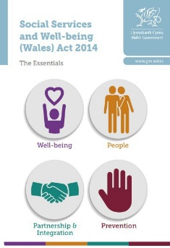
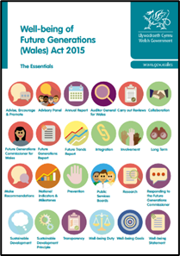
Key Legislation

The Social Services and Wellbeing (Wales) Act 2014 The Well-being of Future Generations (Wales) Act 2015

Key National Strategies

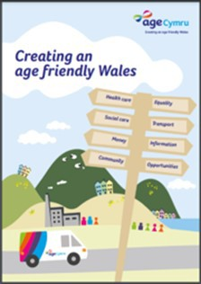
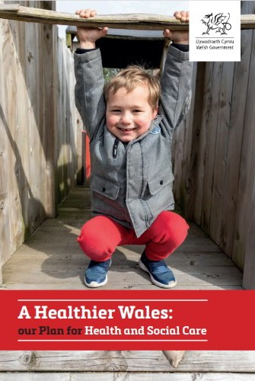
Age Cymru’s Creating an Age Friendly Wales
Welsh Government’s A Healthier Wales: Our Plan for Health and Social Care
The Older People’s Commissioner for Wales:
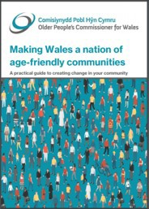
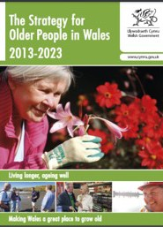
Making Wales a nation of age-friendly communities
Welsh Government’s Strategy for Older People in Wales

Key Local Strategies

Cardiﬀ Well-Being Plan 2018 –2022 Capital Ambition
Cardiﬀ Council’s Older Persons Housing Strategy
The Cardiﬀ and Vale of Glamorgan Integrated Health and Social Care Partnership’s Care and Support Services for Older People 2017-2022
Cardiﬀ and Vale University Health Board’s Shaping our Future Wellbeing Strategy The Cardiﬀ and Vale area plan for care and support needs 2018 – 2023

6

Engagement Sessions
As part of the drafting of this strategy, in early 2020, engagement sessions were held with both internal and external partners.
One session was held with senior managers within Adult Services while a separate session was held with external partners at the Cardiﬀ Health, Social Care and Wellbeing Network. Attendees from ten diﬀerent third sector organisations took part in the event.
The proposed main themes of the Strategy were shared and formed the basis of discussions. A questionnaire was provided so the views of service users could also be obtained. The quotes below outline some views of those individuals who have received support from Adult Services.
“Work with a smile, be friendly make people feel safe valued and trusted”
“Provide a preventative service not a reactive service”
“I have concerns around technology enabled care. It must not replace human contact.”
“Use plain language not workplace language to make sure I understand what support is on oﬀer and how you will help me”
“My individual voice is important”

The following key themes emerged from the sessions which have informed the development of the principles and key aims of the Strategy.

Prevention
Person Centred
Technology-enabled care



Collaboration Community



7

The Cardiﬀ Ageing Well Strategy 2022 - 2027 sets out an overarching vision for services for older people in Cardiﬀ. Supporting this vision are a number of principles and key aims that have been developed from a review of strategic documents, current services and consultation with partners and service users. Emerging ﬁndings from the population needs assessment have been taken into account, including the views of citizens. Each key aim forms a section of the Strategy and they are supported by “we will” commitments. These principles and key aims will shape and inform our service over the next ﬁve years.

Our Vision
Supporting older people to live well in their homes and communities

Our Principles

- Older people will have Voice and Control

- We will take a strengths-based
approach

- We will support and enable independence

- We will provide the right help at the right time
- We will deliver outcome focused services

- We will work collaboratively with partners, third sector and citizens

- We will value diversity and promote equality

- We will ensure that our social care workforce is well trained and feel valued

Our Key Aims
Supporting older people to stay active and connected in an age friendly city Supporting older people to live independently at home through strengths-based preventative services
Working in partnership to deliver high quality sustainable care and support Supporting informal carers and valuing their role
Ensuring our services meet the needs of the most vulnerable
Proactively modernising our services

·
·

·
·
·
·

8

Hubs with a focus on Wellbeing
We want to ensure that all older people in Cardiﬀ have access to the right advice, support, activities and services to help them stay healthy and independent. Located at the heart of our communities and bringing together a range of services based on local needs, our Community Hubs are well placed to assist in tackling many of the issues that aﬀect the health and wellbeing of older people, including social isolation.
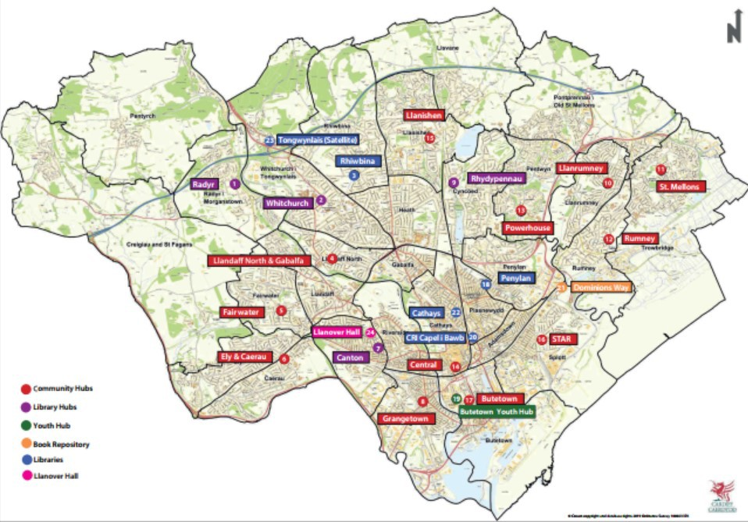

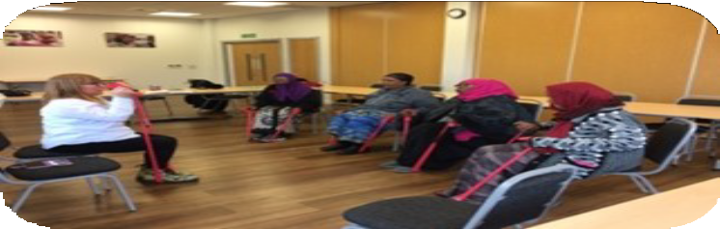
The Hubs support the Healthy Living agenda by providing venues for partners to deliver a wide range of physical activities, sport and other opportunities for older people to stay ﬁt alongside a range of social activities to prevent isolation and loneliness, all in relaxed community setti ng.

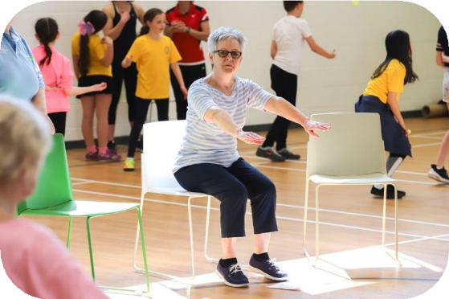
Our Libraries in the North of the city are being transformed into Hubs – with a focus on wellbeing. These hubs will provide health and independent living advice, social events and groups and intergenerational activities all within a local setti ng.

9

Supporting older people to stay active and connected in an age friendly city

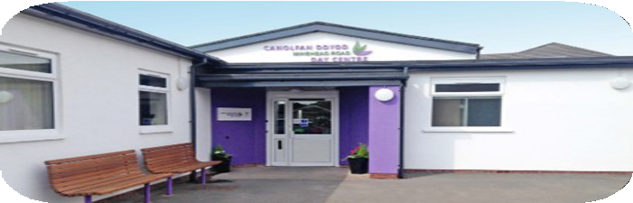
Joined up working between Day Centres and Hubs
Cardiﬀ Council operates three Day Centres that provide services
to older people with high care and support needs.
Over recent years refurbishment work has been undertaken with the aim of providing a good quality day care environment for older people with high level of care and support needs
and a low or stable level of Dementia, with a more specialist Dementia Day Centre in Ely provided in partnership with the Health Board.
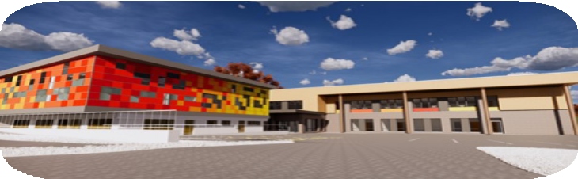
We will bring the partnership approach of the hubs into the older persons Day Centres to provide additional activities, events, and advice. We will encourage partners to deliver services in the Day Centres and further encourage volunteering. The Day Centres can assist the hubs by ensuring their activities are accessible to people with higher care and support needs.

Joined up working between Health and Hubs.
Work is underway to extend our Powerhouse Community Hub to be the ﬁrst Health and Wellbeing Hub in Cardiﬀ, oﬀering a GP practice and a wide range of health services alongside our normal hub provision, providing even more
opportunities to support older people to stay healthy and connected.
Health and Wellbeing Hub under development in Llanedeyrn

We will extend opportunities for older people with care and support needs to stay connected by:
  - Bringing together Community Hub and Day Centre Services - increasing the range of activities provided in the Day Centres, encouraging partners to deliver services and further encourage volunteering.
  - Developing a Hubs for All approach—this could include:
    - Using the specialist knowledge of the Day Centre team to assist the hubs to make their activities accessible to people with higher care and support needs.
    - Dedicated sessions for those with care and support needs with support / care staﬀ available.
    - Make use of the days that some Hubs are closed and weekends in the Day Centres—to extend the services available and provider additional respite for carers.
- Working with the Health Board to further develop our hubs to deliver integrated
Health and Wellbeing Centres. 10


Becoming an Age Friendly City
Age-friendly cities’ are a concept developed by the World Health Organisation (WHO), focused on creating environments which foster healthy and active ageing, making it possible for people to continue to stay in their homes, participate in the activities they value, and contribute to their communities for as long as possible.
We are in the process of applying to become an Age Friendly City in collaboration with the Regional Partnership Board partners and the Older People’s Commissioner. To do this we have set out a Cardiﬀ ‘Working Towards an Age Friendly City” action plan. The World Health Organisation have set out 8 domains to describe age friendly cities and these domains have been used as a framework for the development of the plan. Our plan includes:

Outdoor space and public buildings - including a Toilet Strategy to ensure adequate provision and improved access to public toilets across the city. Promoting safe and age friendly design of buildings and spaces

Community Support & Health -
Delivering support in a locality based setti ng delivering a network of support
based on what matters to the individual.
Communication & Information - providing access to information that helps people with their wellbeing.

Housing - including the vision of the Cardiﬀ Older Persons Housing Strategy to deliver the best housing outcomes for all older people in Cardiﬀ. This includes increasing the provision of extra care housing and the supply of care ready housing. Together with a commitment to provide person centred information and assistance.
Transport - supporting improvements that will facilitate better access. Making sure that everywhere in our city is open and accessible to everyone and that all public services are connected by our transport network.

Social Participation - bringing people together through social groups providing opportunities to connect with others.

Respect & Social Inclusion - Bringing generations together to promote greater understanding and respect and contribute to building more cohesive communities.
Civic Participation & Employment - enabling older people to have a voice in issues that aﬀect them. Into work services
provide support for older people to access
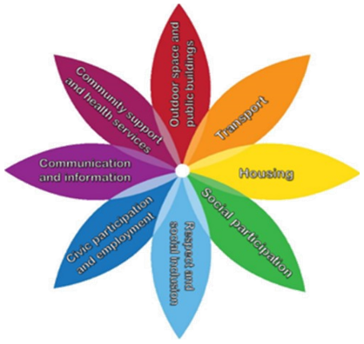
employment.
11

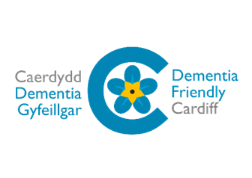
Becoming a Dementia Friendly City
By 2025 there are projected to be approximately 7,000 people living with Dementia across Cardiﬀ and the Vale of Glamorgan. In line with the Regional Partnership Board’s priorities, Cardiﬀ’s Public Services Board has committed to making Cardiﬀ a Dementia Friendly City.
We will continue our work as a Dementia Friendly City by:
- Continuing to roll out the mandatory Dementia Friends e-training across the Authority with the aim of full compliance amongst Council staﬀ.
- Developing a school engagement programme to encourage more inter-generational activities and events.
- Working with volunteers and partners to encouraging businesses to become Dementia Friendly.
- Ensuring that a wide range of events takes place within the city that people with Dementia and carers can access.
- Facilitating the consideration of Dementia Friendly Design in the refurbishment of council buildings and reviewing our public buildings to make modiﬁcations that support those living with dementia to remain active within their community.

Community Groups and Volunteering
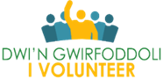
I Our third sector partners and voluntary groups play a crucial role both in supporting older people and in providing opportunities for older people to stay involved in their communities through volunteering. Cardiﬀ Council’s volunteering
portal enables community organisations to advertise their opportunities all in one place. Those who want to help can look at these opportunities knowing that the organisations have been vetted.
The successful “Together for Cardiﬀ” partnership, launched during the pandemic brought third sector partners and voluntary groups together to support those isolating. This is to be relaunched to encourage volunteers to support older people in the city.
We will support people to stay active and connected and to prepare for the future by:
·
Reviewing and strengthening the independent living & wellbeing advice provided in
the Hubs for older people and their carers.
·

·
Working to become a World Health Organisation Age-Friendly City - by delivering the
Age-Friendly City Action Plan.
Continuing our work towards a Dementia Friendly City.
·
Supporting community groups and volunteers to support older people and carers.
12

Staying Connected

Mrs L had recently retired, her family didn’t live close to her and she was at risk of becoming socially isolated. During the pandemic Mrs L’s health issues worsened as she was not able to remain active.
Mrs L attended the ‘Active Body, Healthy Mind’ virtual Spring Festival and was referred into the Day Opportunities Team Digital Inclusion Service.
Mrs L was gifted a pedometer, to monitor her activity. The pedometer has become a motivational tool to increase her activity and steps.
Mrs L is now a member of an online walking group. She also regularly attends groups based on her hobbies, including the local history society, a monthly reminiscence group, knit and natter, Tai- Chi and a Mindfulness group.
Mrs L said it had become ’quite scary’ how inactive she became during lockdown, however recently her watch showed 6,000 steps in one day!

Community Engagement & Wellbeing Team
Our Community Engagement & Wellbeing Team work with older people to identify their interests and to ﬁnd suitable community activities, including intergenerational events, to reduce social isolation.
There is a strong focus on enablement and removing barriers to community participation, by ﬁnding solutions with the service user.

Staying Virtual – the Hybrid Model
During the pandemic, virtual activities and events were developed by the Council and partners to ensure that older people and the most vulnerable were supported by using digital solutions as a way to reduce social isolation.

Independent Living Services – Virtual Festivals These festivals have brought together Council services and third sector partners to support older and more vulnerable residents in Cardiﬀ to remain healthy, well and independent, as well becoming digitally included.

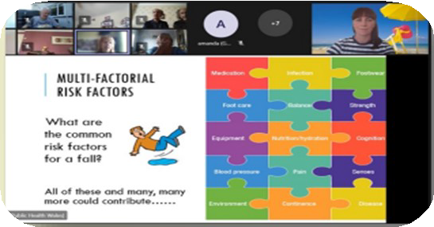
While face to face activities are important to many older people, digital events also proved popular, allowing many to attend who could not do so in person.

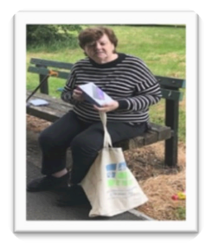

Tablet Gifting Scheme

We will support people to stay active and connected and to prepare for the future by:
  - Providing both virtual activities and events and face to face activities through a hybrid model of community engagement.
  - Continuing to support older people to get online.

13

Developing and joining up services to better support older people
We already have very successful services with a focus on independence, but we want to improve these. We want to embed a strengths-based, outcome focused and preventative approach across the service ensuring that all staﬀ are appropriately trained to take this forward. Our core services are:

Community Occupational Therapy Team
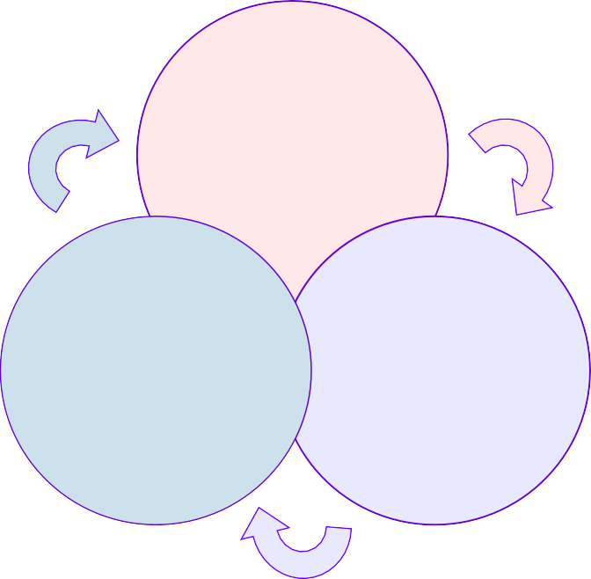
Our Community Occupational Therapy Team oﬀers practical support to enable people to live as independently in their own homes for as long as possible. Through use of equipment aids and adaptations, they help people remain independent at home and ensure that care packages are “right sized”.

Independent Living Service
Our Independent Living Service has already developed a range of successful preventative services – working closely with other council services, the third Sector, the Health Board and community groups co-producing outcomes that matter to citizens and supporting independence.
Independent
Living
Occupational
Therapy
Social
Work

Social Work Teams

Our Social Work Teams have been trained in strength-based practice through the delivery of Collaborative Communication training. This has supported a change in model of social work throughout the service.
In 2020/21 in 84% of new referrals for assistance, help was provided by the Independent Living Service with no onward referral to social care

Strength-based practice is now more evident in all the work that we do, with a renewed focus on delivering person-centred services that build on an individual’s own assets and strengths.

We will continue to develop and join up services to better support older people.
14

Increasing the involvement of Occupational Therapists

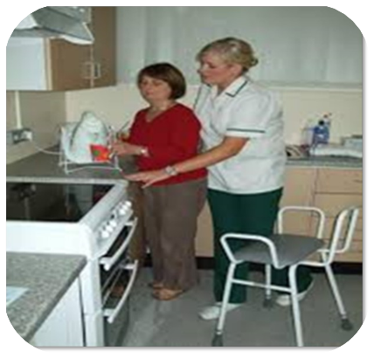

Case Study

Mrs J has advanced dementia, diﬃculty walking and becomes unsteady when standing. She had recently had her
care package increased to double-handed care, however carers were still struggling to support her.
In order to assess the issues raised by carers, an Occupational
Therapist attended a morning call to observe the diﬃculties the carers were
experiencing. It was established that a hoist was needed to assist with getting Mrs J out of bed and completing personal care tasks. A mobile hoist was delivered initially but was not successful so it was agreed to install ceiling tracking into the property.

Mrs J is able to remain at home despite her high level of care and support needs. Both Mrs J's husband and the care agency conﬁrmed that caring for Mrs J is now so much easier.

We will embed a strengths based and preventative approaches across the services to help people stay independent at home:
We will increase the involvement of Occupational Therapists:
    - Making full use of their expertise in equipment and adaptations throughout
our services.
    - Providing a strengths-based triage, enabling prevention and rightsizing of care packages.
    - Providing tailored support for informal carers.

We will ensure that our social workers and other key staﬀ have the training they need to deliver outcome-focused, strength-based assessments - taking an asset-based approach, focused on enabling people to live independently, in their homes and communities.

15

Supporting older people to live independently at home through strengths-based preventative services

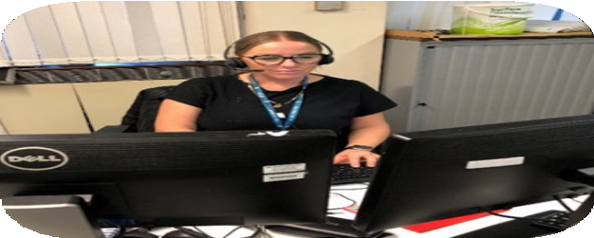
First Point of Contact
The First Point of Contact Team (FPOC) are a team of multi- skilled telephony oﬃcers who are the ﬁrst point of contact for new referrals into the Independent Living Service and Social Care. Oﬃcers work in partnership with the client to support them to identify and remove barriers which may be preventing them from reaching their well-being goals.
They provide valuable information, advice and assistance to avoid people getting into crisis by identifying “what matters” to them, working in partnership with Social Care teams on the provision of signposting, tailored information and advice to ﬁnd alternative solutions.

First Point of Contact - Social Work Team
The First Point of Contact Social Work Team ensure that there is always professional help available to support the contact oﬃcers and to review and assist more complex cases.

We want to further improve access to our services by building on the success and ensure that everyone receives the help they need to stay independent at home. We will do this by further enhancing our First Point of Contact service and consolidating this as the single route into our services for older people.

We will strengthen and streamline services at our front door to support prevention and
reablement by:
·
Building on our First Point of Contact Service and consolidate this as the single route
into all our services for older people, reducing duplication and ensuring a consistent approach to prevention and reablement.
·
Empowering our Social Workers and Independent Living Contact & Wellbeing
Oﬃcers to prescribe low level adaptations and equipment.
We will work towards a single front door approach for both social care and community
health services.

16

Locality Working Supporting an “At Home” Approach
Locality working delivers place-based, joined-up care and support across Health, council, third sector services and local community networks. The model of support is designed around the person and their family/support network with targeted actions to meet local needs.
We are working together with partners from the Regional Partnership Board on the Ageing Well @ home programme to deliver place-based joined up care and support across the Health Board, council, third sector services and community networks.
We will work with our partners to develop local integrated multi-disciplinary teams which can better meet the needs of the people who we jointly support. The aim is to dissolve the boundaries between services so that people experience care and support when they need it, focused on keeping people healthy and independent.
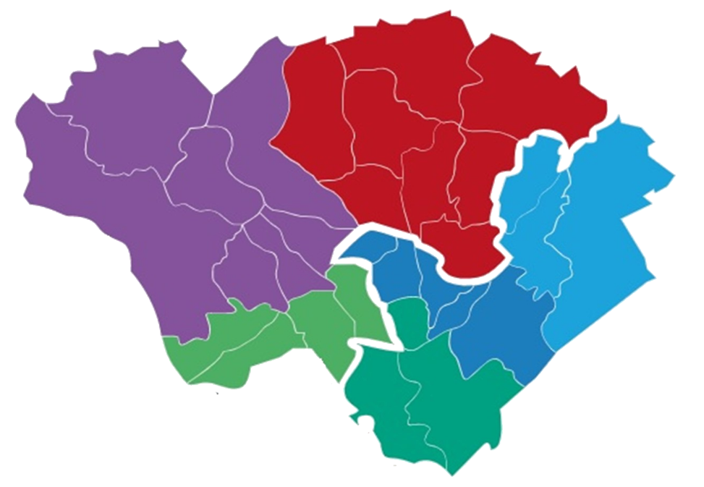

The localities will mirror those of the six GP clusters within Cardiﬀ, but the service will be split into two locality settings, North West and South East. These will cover
three clusters per locality.

Cardiﬀ West
Cardiﬀ North

Cardiﬀ East

Cardiﬀ South West
Cardiﬀ South
East City & Cardiﬀ
South

We will work together with health colleagues through the @ home project to develop integrated Local Multi Disciplinary Teams, including a wide range of council and health services:
  - Establishing easily accessible locations within the community for our joined up teams enabling them to deliver shared priorities.
  - Providing the right help at the right time in the community, focused on staying home and healthy and facilitating hospital discharge.
  - Ensuring help is available locally - when it is needed to support independence and prevent crisis.
  - Continue to work with GP clusters to meet the holistic needs of citizens. 17

Homecare Service
The Community Resource Team (CRT) is a joint service provided by Cardiﬀ and Vale University Health Board and Cardiﬀ Council.
CRT supports people to stay at home or return home from hospital through health and care services and through reablement support.
The Council provides a Home Care Service as part of the CRT, delivering much needed personal care, but with a focus on reablement.
We will explore the opportunity to build on our integrated CRT service to deliver a joined up rapid response 24/7 service to continue to keep people at home.
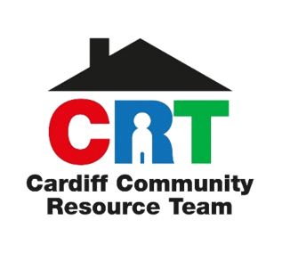
CRT Case Study
Mrs B was admitted to hospital as a result of heart failure. She recovered well in hospital but it was identiﬁed that she may need support with washing and dressing, as well as ongoing physiotherapy to progress her mobility.
Mrs B was very independent prior to her admission so she was referred to the CRT for reablement support. A conversation took place with Mrs B to understand what mattered to her, what she could do and what her goals were.
Regaining her independence and being able to access the community was very important to Mrs B so a number of resources were put in place to help her.
An emergency alarm was organised through Telecare and Meals on Wheels were arranged, also access to the Falls Clinic. Both a Physiotherapist and an Occupational Therapist were involved in developing a personal care plan to assist with mobility issues.
Mrs B was referred to the Day Opportunities Team to regain her conﬁdence in accessing community activities.
This collaborative working prevented the need for a long term package of care and increased independence for Mrs B.
“The carers have been wonderful, I feel like a new woman which is thanks to all of you!”

We will work in partnership with our health colleagues to move towards a more
integrated approach to community resource services.
We will modernise our homecare services to:
  - Provide a full Reablement Service - upskilling our current care staﬀ to be reablement oﬃcers.
  - Provide a Bridging Service for short periods to achieve rapid discharge from hospital or to support continued independence.
  - Create a career pathway for our inhouse care workers to help recruitment and retention.

We will work with our health partners to develop a rapid response 24/7 service to keep
people at home.
18

Supporting Hospital Discharge

Hospital Social Workers
Hospital Social Workers are based in hospitals across Cardiﬀ and the Vale. They aim to facilitate safe and timely discharge for those who have eligible needs for care and support. Assisting those who will be moving into a care home placement, moving to a health setti ng or returning to their own home with a care service.
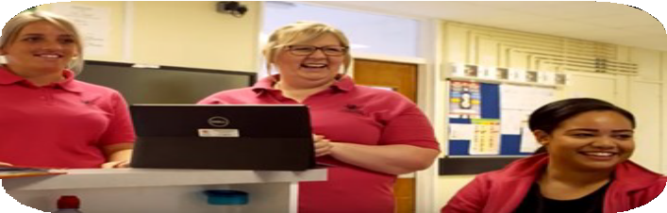
The “Pink Army”
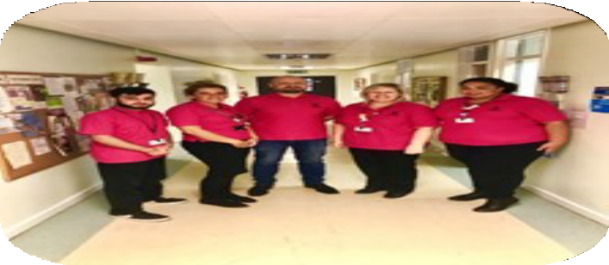
The “Pink Army” is part of our Independent Living service, it works in the hospital wards to support the transition from hospital to home in partnership with Health, Social Care and the 3rd Sector. They are on hand to provide tailored support that meets the needs of the individual, providing preventative interventions, supporting independent living and reducing the risk of readmission.

Community Occupational Therapist
A recent pilot of a Community Occupational Therapist working alongside social work in the hospital reduced the home care individuals needed and prevented admission to residential care.

We will support timely and safe hospital discharge by:
- Having a single point of contact in the hospital which is fully aligned to our community, strengths based model. To ensure safe & timely discharge, following Home First principles and empowering independence.
- Incorporating the skills of our Community Occupational Therapists in the hospital, developing an enhanced triage process, to support independence.
- Reﬁning and simplify the Discharge to Recover and Assess model – assessing care needs in a persons home and not the hospital.

19

Improving the Use of Technology

Telecare or Technology Enabled Care (TEC) uses a combination of alarms, sensors and other equipment to help people live independently.

Research from across the world shows independent living can be extended when older people (aged 75+) are encouraged to take up telecare. 4,419 people over the age of 75 currently use our Telecare services, although this equates to 71% of all Telecare users, it equates to just 18% of the 75+ population in the city.

We want to encourage greater use of technology, including mainstream technology such as voice activated devices, to help more people stay independent for longer. Technology will not replace the need for human contact, however it can be an important tool alongside other support to help people to remain at home.



A focus on Telecare
In 2020/21, 230,763 calls were taken.
Telecare mobile wardens attended 3,614 fallers, resulting in estimated cost avoidance for the Welsh Ambulance Service of
£703,154 for the year.

Service delivery was maintained throughout the whole of the pandemic.

We will improve the use of technology, aids and adaptations to support independence
by:
·
Developing a cutti ng edge Cardiﬀ Tech Strategy based on the best practice from
across the world and providing tech support to embed this, ensuring all our staﬀ are trained to make appropriate referrals.
·
Introducing a “tech ﬁnder tool” for staﬀ and citizens alike, which will empower our
citizens to make their own choices and self purchases as well as being a support tool for assessments by our staﬀ.
20

Improving the Use of Aids and Adaptations
Aids, equipment and adaptations improve movement and access around the house and can play an important role in keeping older people independent for longer.

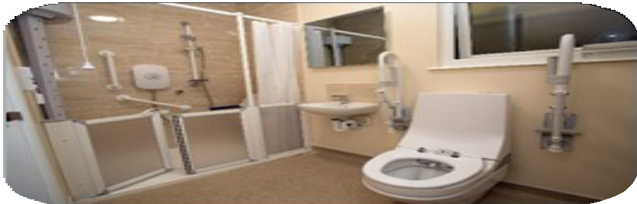
Disabled Facilities Team
The Disabled Facilities Team delivers a range of adaptations to the home. This may include preventative low level works such as hand and grab rails. More signiﬁcant works will be assessed by an Occupational Therapist who will ensure the adaptation fully meets the needs of the older person.
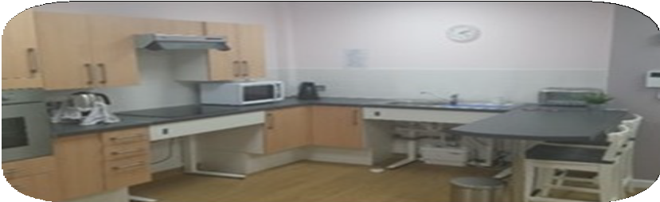
In 2020/21, 984 home adaptations were delivered to help older people to continue to live independently, but we would like to improve on this and increase the number of adaptations we provide.

The Joint Equipment Service (JES) is an integrated service providing an eﬃcient community equipment loan service to residents of Cardiﬀ and the Vale of Glamorgan. They deliver and install specialist equipment upon receipt of referrals from community and hospital clinicians.
In 2020/21 – JES
completed 572 same or next working day deliveries – a 97% increase on 2019/20
The service enables a timely discharge from hospital by providing the equipment required to facilitate that discharge. The service also facilitates the provision of equipment to support the reduction of care as part of a care review process.

21

Proposed Independent Living Wellbeing Centre
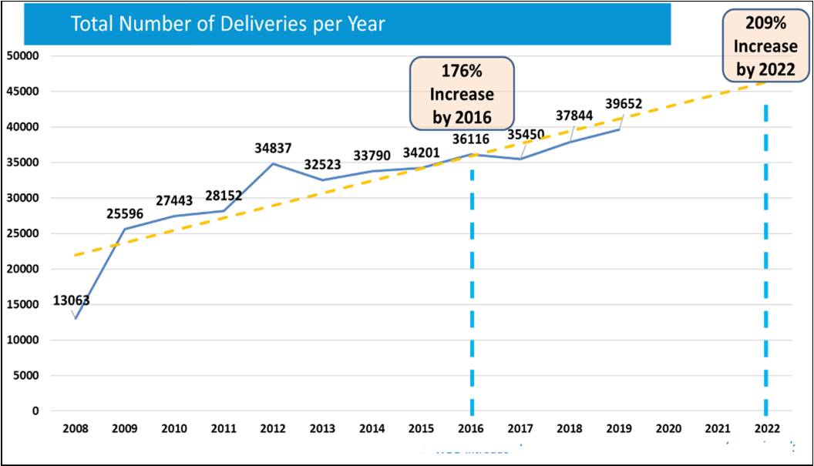


With the continued growth of the Joint Equipment Service, we propose to build on the success of the services and to develop an Independent Living Wellbeing Centre.

The proposal would see the development of a single integrated facility for Cardiﬀ and the Vale Councils and the Health Board, to act as a centre for independent living.
It would contain a distribution centre for equipment and include a new smart house facility for training council staﬀ and the wider health and social care sector. The smart house facility would also be used to assess individuals to ensure equipment is appropriate to their needs.
The Centre would include a public-facing facility to enable individuals to understand what equipment is available to assist with independent living and to purchase practical equipment solutions to meet their independent living needs.
It is anticipated that the facility would be host to multidisciplinary teams to develop solutions for the multiple issues faced by older people trying to live independently in the community.

We will improve the use of technology, aids and adaptations to support independence
by :
·
Developing proposals for an Independent Living Wellbeing Centre, rationalising our
existing joint equipment stores and developing a public facing facility focused on practical solutions to support independent living.
·
Removing the means test from all eligible disabled adaptations.
·
Expanding the recycling of equipment and adaptations.
22

Providing advice and support to help move
The ﬁndings from a range of research shows the beneﬁts of suitable older persons’ housing in supporting independence and reducing the need for residential care.

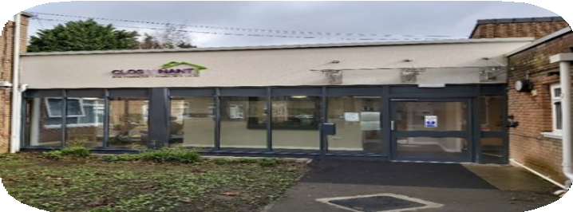
Rehousing Solutions Team
Our Rehousing Solutions Team provides specialist housing advice for older people to help them understand their housing options and support them towards tailored solutions.

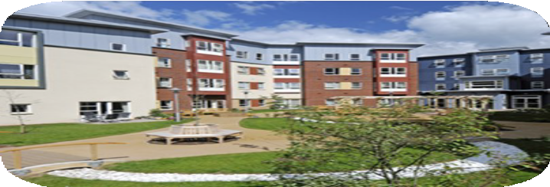
The aim will be to ensure that high quality advice and information about housing solutions for older people is available on the Council website, in hubs and through information sessions and events.

Our Housing Association partners provide Extra Care Housing which can help people remain independent and avoid residential care. We want to expand on this and other specialist housing options available for older people.

We will promote the move to more appropriate housing where this will support
independence by:
·
Encouraging people to think about their long term housing needs at the earliest
opportunity by providing eﬀective information and advice.
·
Finding tailored housing solutions to help people remain independent.
·
Reviewing our use of extra care / community living housing, as an alternative to
residential homes for both respite and permanent care.
23

Developing New Accommodation
The Council and partner Registered Social Landlords are committed to continuing to deliver new aﬀordable housing speciﬁcally for older people - accessible/ﬂexible accommodation that allows for ageing in walkable neighbourhoods within easy reach of local services and activities.
Approximately 700 units of aﬀordable older persons’ accommodation are planned over the period 2020 to 2030 to deliver purpose built, accessible and sustainable community living schemes providing a ‘home for life’ which enables a resident to live independently.

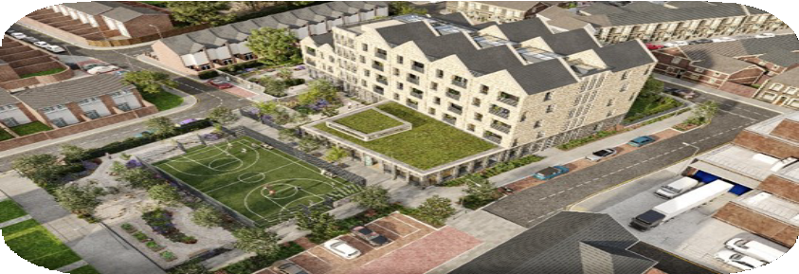
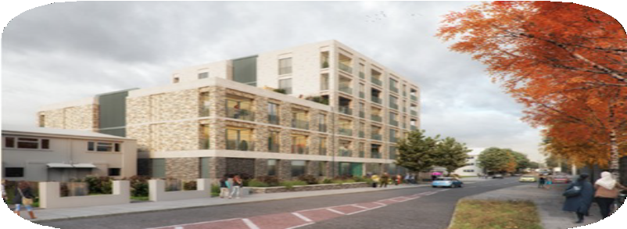

Proposed Canton/Riverside Community Living project

Proposed Community Living in Butetown


We will ensure our new housing developments support people to remain independent
by:
·
Building care ready, adapted, and adaptable homes.
·
Building community living schemes for older people that can meet Cardiﬀ’s changing
need.
Proposed redevelopment of Channel View

24

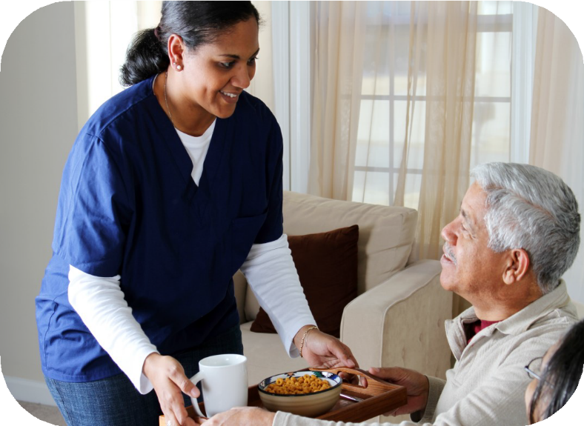
Providing Domiciliary Care
We currently work with 54 domiciliary care agencies across Cardiﬀ to support around 2,000 people who need additional help to remain living independently. Agencies deliver around 27,000 hours of care a week, providing an essential service to the most vulnerable people in the city. Care providers have worked throughout the pandemic to deliver quality care in both home and residential settings.
The issues with the current care market are clear. There has been a surge in demand following the pandemic and this has revealed systemic weaknesses in domiciliary care provision. There are also problems in recruiting and retaining staﬀ and issues with rates of pay.
We will work in partnership with commissioned care providers to better understand these issues. In particular, we will work with the domiciliary care agencies to deliver ﬂexible person-centred care, developing a trusted partnership agreement with care agencies, allowing them to ﬂex care provision in response to an individual’s care needs and wellbeing objectives.

We will work in partnership with our commissioned domiciliary care agencies to deliver ﬂexible person centred care by:
  - Increasing our understanding of the issues faced by the domiciliary care agencies and providing support.
  - Putti ng in place a Trusted Partnership agreement with our care providers so they are able to adapt an individual’s the care in an appropriate and timely manner.
  - Our care providers will have Local Care Co-ordinators who will become part of our multi agency locality teams.

We will ensure a seamless transition from a council homecare / reablement service to long term Domiciliary Care.

25

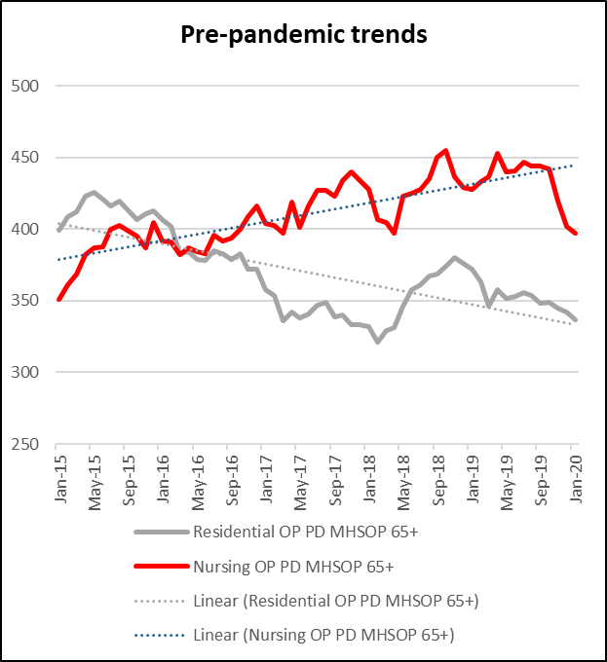
Residential Care
Prior to the pandemic the use of council funded residential care was reducing while nursing care was increasing. During the pandemic both of these fell. It is anticipated that as we come out of the pandemic, demand for more specialist provision will increase. Also as we promote and support independence, the need for general residential care will decrease.

Level of Residential Care in Cardiﬀ (Estimated)

Year | Homes without nursing | Homes with Nursing | Places without nursing | Places with nursing | Total Places
2021 | 41 | 21 | 781 | 1,370 | 2,226
The Council purchases less than half of these places
It is more important than ever that we actively seek to inform, manage and reshape the care market in the light of current and future need. Work is underway to better understand this need through the development of a Population Needs Assessment and a Regional Market Sustainability Report.
Future proposals are likely to see the service working with the residential care sector to move away from general residential provision towards more specialist dementia residential and dementia nursing care.
We will seek to inform, manage and reshape the care market by:
·
Understanding future care and support requirements in the light of Regional
Market Sustainability Report (due June 2022) / Population Needs Assessment and communicating this to the care sector.
·

·
Working with the care sector to move away from general residential towards
home based care.
Promoting the development of additional high quality dementia residential and dementia nursing care.
26

Supporting Voice and Control in the provision of care
Listening to our citizens and tailoring the care and support towards their chosen outcomes will be at the heart of all our services. This is particularly important in the commissioning of care, ensuring there is suﬃcient ﬂexibility to meet individual need.

Direct Payments
Direct Payments are one of the fastest growing methods of meeting the outcomes of people in Wales, and it is our aim to ensure that as many people as possible are able to beneﬁt from them.
Direct Payments enable people to arrange care and services themselves, to have more choice and control over the services they receive, ensuring care is provided in a more convenient and ﬂexible way.
Our partner Dewis Centre for Independent Living supports people through the process.
However despite the support available, taking on responsibility for employing a carer directly can be a daunting prospect for some older people. We will explore other ways that we can assist older people to take control over their own care, this may include encouraging the establishment of micro-enterprises to oﬀer more choice to our citizens.

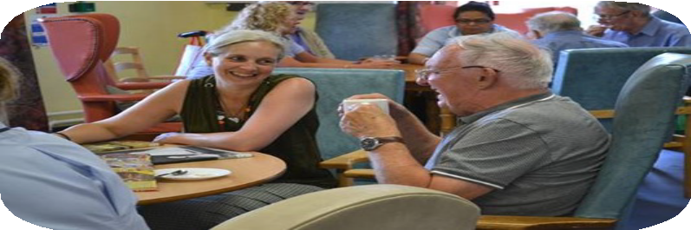

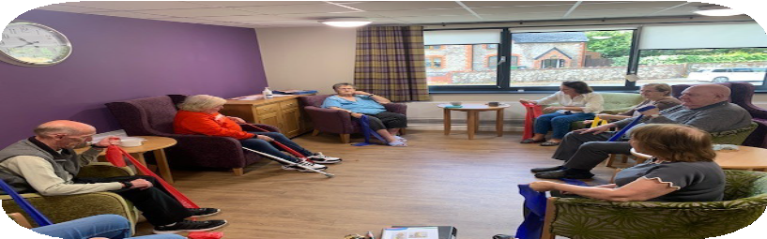

650 people in Cardiﬀ already employ their own Personal Assistant to meet this social care needs

We will increase the voice and control of citizens in our commissioning of care and
support services:
·
Supporting individual voice and control by focusing on wellbeing outcomes.
·
Reviewing how we consult and co-produce services with older people.
·
Reviewing our support for direct payments and increasing the supply of well
trained personal assistants.
·
Exploring the provision of care through local micro-enterprises.
·
Moving away from “task and ﬁnish” approach to care to focus on wellbeing
outcomes.
27
Working in partnership to deliver high quality sustainable care and support

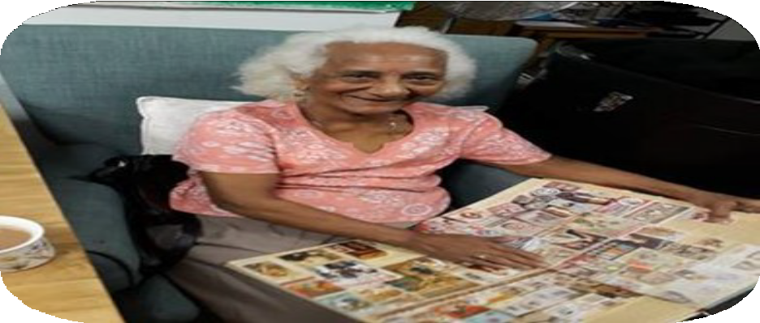
What does good care look like?
Using ICF funding, our team of professionals is visiting care homes in Cardiﬀ to understand “what good looks like” – identifying and promoting local best practice.
Meanwhile, we have commissioned research to look across the UK and the world to identify best practice in social care provision for our citizens with the highest needs.

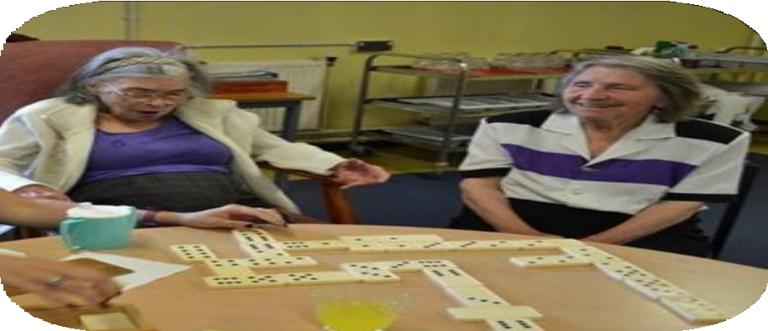

This work will inform our future commissioning of services and allow us to develop more eﬀective quality monitoring arrangements that focus on ensuring that we deliver an excellent quality of service for our most vulnerable citizens.

We will improve the quality of care provided through commissioned services by:
- Developing a clear view of “what good looks like” in dementia residential and nursing homes to inform future commissioning.
- Ensuring that eﬀective quality monitoring is in place that focuses on the care
provided and the views of the individuals, their family, and care network.
- Co-producing a Regional Quality Framework for care homes underpinned by local quality assurance arrangements.
- Reviewing Quality Ratings for both domiciliary and residential care.
- Relaunching the Escalating Concerns process to support providers to improve when things go wrong and to ensure immediate action / intervention where there are safeguarding concerns.

28

Working in partnership to deliver high quality sustainable care and support

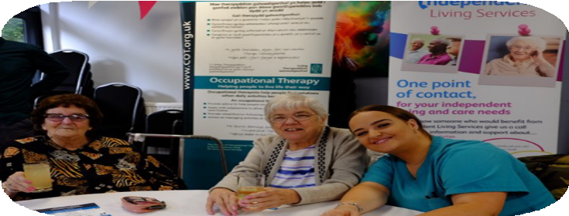
Valuing the Social Care Workforce
Valuing and developing the Social Care workforce is key if good quality care is to be provided. Although the issues with the care workforce is a national one, Cardiﬀ's employment market provides additional challenges. A recent review showed distinctive features of the workforce in Cardiﬀ.


High Turnover
We have the highest proportion of social care staﬀ who joined within the last 12 months (37%) and the lowest proportion on permanent contracts (72%).
Low Qualiﬁcation Levels
The proportion of managers and care staﬀ with the required or recommended qualiﬁcations is lower in Cardiﬀ than other areas:
- 73% of managers compared to 83% for Wales
- 71% of senior care workers compared with 82% for
Wales
- 45% of care workers compared with 61% for Wales

Cardiﬀ Cares Academy recruit and train new Care Workers for the city’s social care sector. They provide informative sessions about what the role involves including training, with tailored support provided every step of the way.

Welsh Government has recently announced additional funding to enable local authorities to implement the Real Living Wage within the care sector. We will work with Welsh Government to ensure that this is implemented in the most eﬀective way possible.
We will value and develop the Social Care Workforce by:
·
Further developing Cardiﬀ Cares Academy to provide training, mentoring and
employer support.
·
Providing proactive support to help care workers to achieve registration.
·
Working in partnership with providers to grow the workforce – including through
our Care Development Contracts.
·
Working with the Welsh Government to implement the Real Living Wage for care
workers in Cardiﬀ.
·
Working collaboratively with all key stakeholders across the region as part of the
Social Care Regional Workforce Partnership. 29

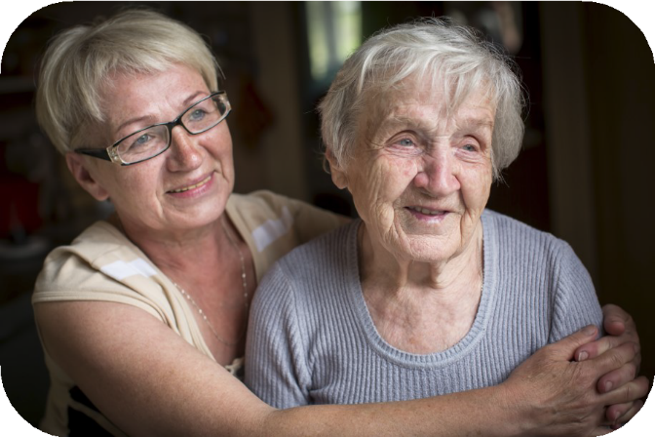
Supporting Carers

We recognise the vital contribution that informal or unpaid carers make to
communities and the people they care for. We also understand the pressure that caring for a loved one can cause, especially if the carer is also an older person themselves or is carrying out their care role while in full time work.
We are committed to ensuring
that carers are recognised, and that every step is taken to ensure we support the highest quality of life both for those providing and in receipt of care. We will review the support for carers in full consultation with carer representatives.

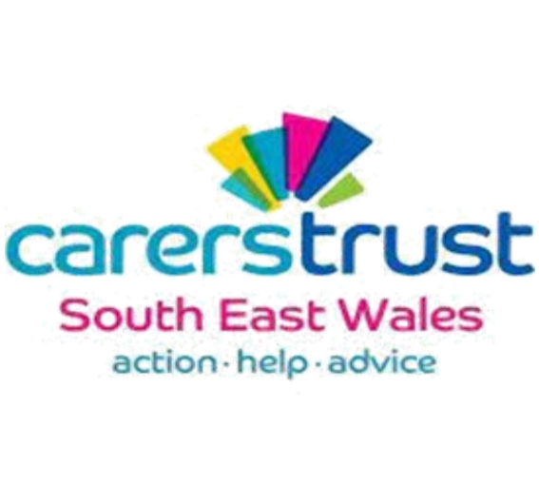
The cost of replacing informal or unpaid care with formal care is estimated at £8 billion for Wales

The Cardiﬀ and Vale Carers Gateway provides
help and support for informal carers.
10 carers Expert Panels were held in 2020/21 consulting carers on a wide variety of issues.

We will support and value informal carers by:
  - Reviewing our advice services for carers to ensure they meet current needs.
  - Evaluating the current carer’s assessment process and explore how take up of these can be improved.
  - Oﬀering Occupational Therapy support to enable carers to safely support their loved ones.
  - Reviewing the range of respite provided.
  - Consulting and co-producing any changes with carers.

30

Supporting those living with Dementia
Mental Health Services for
Older People (MHSOP), a regional partnership, provides secondary mental health services to adults over the age of 65. This multi- disciplinary team is integral to the holistic delivery of
services.
Our ambition for Cardiﬀ is to be a Dementia Friendly City and we aim to work in the best way for those living with dementia.

We want to understand how we can best support people with dementia to live in the community.
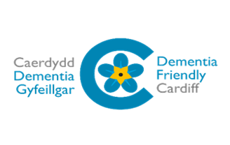
We want to embed research-based practice into our approach and to use the learning from this research to inﬂuence the way in which we approach commissioning services in social care. Consideration will be been given to national and local policy documents which set out how to deliver improved dementia services.

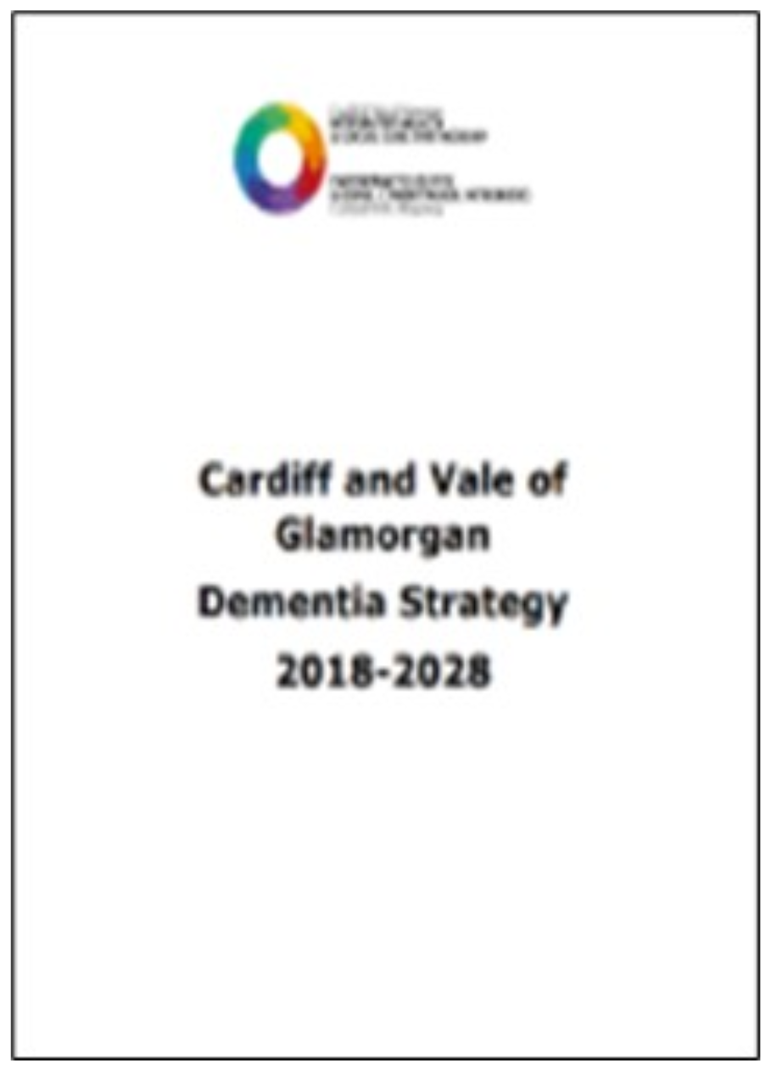
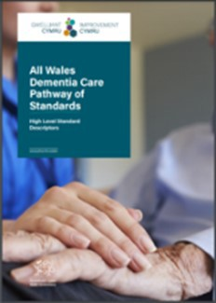
It is estimated that the number of
people living with dementia in Cardiﬀ will increase by 30.1% by 2030 and by 41.1% for severe
dementia.

We will ensure we support people with dementia to stay at home wherever possible
by:
·
Reviewing best practice from across the world to understand how we can best
support people with dementia to live in the community.
·

·
Providing dementia training to all staﬀ to enable them to tailor the correct support
to the person and their family in their home.
Using all the latest technology to support client care.

31

Liberty Protection Safeguards Legislation
Liberty Protection Safeguards legislation will be introduced in 2022. This new legislation supports the rights of those whose capacity is impaired.
We will fully train our staﬀ to apply this legislation in a person centred way will be key to the success of the approach.

Retaining Voice & Control

We will take a strengths-based approach which places the individual and their needs at the centre of their care and support & support individuals to achieve well-being in every part of their lives.
Ensuring that the citizens voice is still heard when their mental capacity is compromised is particularly important.

The Cardiﬀ and Vale Advocacy Gateway is a single point of access for adults looking for support in the planning and delivery of their care and support.
Advocacy is independent of Social Services, and is there to help individuals get the best experience of working with social care services.
A new joint Cardiﬀ & Vale Advocacy Strategy has been produced which sets out ambitious targets for collaboration and co-production across all areas of Adult Social Care. We will ensure that our Advocacy Services are recommissioned in line with its commitments.

We will ensure older people, however vulnerable, retain a voice in their care by:
·

·
Ensuring our social workers take a strengths based approach to mental capacity
and ensure that as far as possible older people retain voice and control.
Mainstreaming the new Liberty Protection Safeguards within older persons services.
·
Recommissioning our Advocacy Services in line with the commitments set out in
the Cardiﬀ and Vale Advocacy Strategy.

32

Proactively Modernising our Services

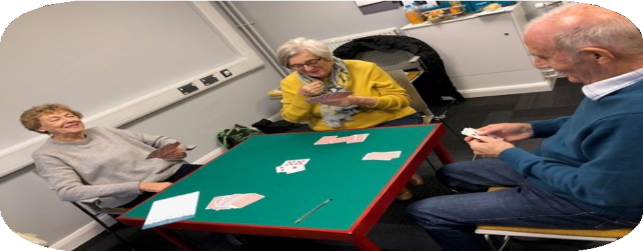
Reviewing and modernising our services
To deliver the aims of this Strategy it will be necessary to modernise services and to embed a strengths-based and independence focused approach in the service, ensuring that training and quality monitoring fully support this approach.
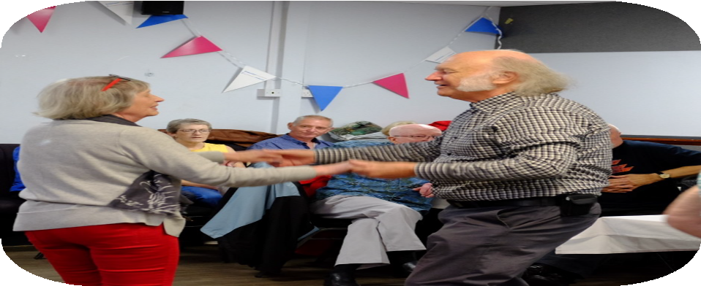
We want to ensure that a wide range of help is available to support all older people to remain independent at home and that all our staﬀ are fully trained to ﬁnd the right help for an older person at the right time.
We also need to ensure that our professionals have the time to support the most vulnerable older people, fully understanding their views and working with them to meet their care and support needs.

We will review and modernise our services to be strengths-based and independence focused by:
    - Restructuring services around our customers needs, in a way that values our
professionals and delivers multidisciplinary locality working.
    - Reviewing and streamlining services – taking a trusted assessor approach, stripping out duplication and costly bureaucracy, ensuring our professionals have the time to support the most vulnerable older people eﬀectively.
    - Reviewing training to ensure that all staﬀ are able to work in a strengths based, trusted assessor basis, taking a holistic view, “prescribing” tech, aids, adaptations, as well as care.
    - Ensure our quality assurance framework delivers high quality strengths-based
social work and care.
33

Addressing Health Inequality
In Cardiﬀ, some of Wales most and least deprived communities can be found within miles of each other. Men living in the least deprived communities can expect to live on average 11 years longer than those who live in the most deprived areas, while the gap is 9 years for women. However, when looking at healthy life expectancy, the diﬀerence more than doubles to 24 years for men and 22 years for women.
Risk factors and mortality for many common conditions are also adversely aﬀected by deprivation, with a signiﬁcant inequality ‘gap’ between those in the most and least-deprived communities. In Cardiﬀ, mortality rates due to poor health are higher in the south of the city. We are working with our Public Health colleagues to address health inequalities in the city.

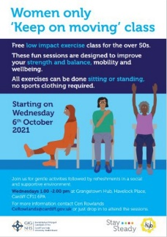

Keep On Moving Class
The Hip fracture data for the Grangetown area shows that this area has one of the highest incidence rates in the whole of Wales with falls a major factor. Cardiﬀ Hubs have worked closely with Cardiﬀ & Vale Public Health Team with the aim of reducing falls in the area.
Following work by the Public Health Team looking into barriers into participation in exercise classes and Stay Steady Clinics within ethnic minority communities, a targeted 5 week trial of LIFT sessions (Low Impact Functional Training - exercises classes for the over 50’s, seated or standing) at Grangetown Hub.
Sessions were carefully promoted as being delivered by a trained female Hub staﬀ member, ‘women only’, with an emphasis on gentle activity and information was produced in Welsh, English, Arabic, Somali, Bengali, Urdu and Gujarati. Sessions times and days were chosen to respect cultural sensitivities. The targeted LIFT sessions are now a permanent ﬁxture in Grangetown Hub’s event programme. Consideration is now being given to a regular visit from a ‘Stay Steady Clinic’ physiotherapist.

Strengthening Welsh language provision
We have created a set of actions to ensure we strengthen Welsh language provision within the service. This includes improving our data collection in order to accurately record and share information on the Welsh language in terms of workforce and service users. It has also recently been agreed that all posts will include Welsh language skills as a desirable requirement. We will also identify service areas who could most beneﬁt from further training and would make the most diﬀerence to Welsh Language service provision and improve the
process for allocating Welsh speaking staﬀ to service users. 34


We have analysed the demographic information for individuals
aged 65+ who completed a wellbeing assessment between April 2018 and March 2021.


65% of clients are 80+
22% of clients are 90+

63% own their own home

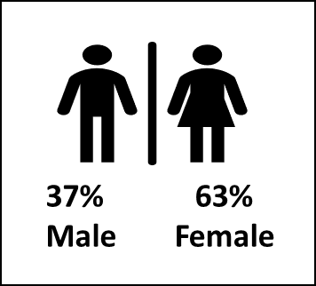

The highest number of clients live in Llanishen, Ely Whitchurch and Rhiwbina.




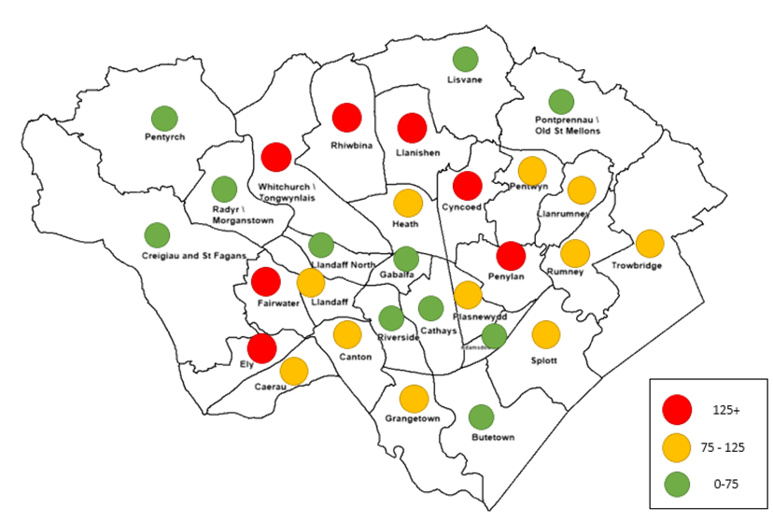
In 2020/21 ethnicity was not recorded for almost a third of all clients.
Where ethnicity was recorded - 95% of clients are white, this compares to 94% of the +65 Cardiﬀ population (according to the 2018 population estimate).
We will improve our recording of ethnicity and seek to better understand the impact of our services on diﬀerent cultures.
We will work with Public Health and other partners to combat the health inequalities across the city.
35

Next Steps
The “We Will” commitments in this strategy set the direction of travel for the next 5 years.

Working together
The Council alone cannot deliver the aims of this strategy. Effective partnership working, and where appropriate greater integration, is essential to ensure that the best outcomes and solutions can be reached. Many areas of the Strategy will require further development, this development will be carried out in collaboration with our partners and citizens.

Funding sources
Delivery of the Ageing Well Strategy is dependent on a number of funding sources. Some proposals have not yet been fully costed and the development of robust business cases will need to be considered prior to implementation, this may include piloting of some solutions before final implementation.

Governance, monitoring and evaluation arrangements
A key next step is the development of detailed implementation plans which will be subject to regular monitoring and review. Clear outcome measures and key performance indicators will be developed to allow evaluation of the work undertaken.

The Strategy will be embedded in the Council’s existing governance and monitoring arrangements, and will inform future corporate plan and directorate delivery plan objectives. Progress will also be reported to the Regional Partnership Board, either as part of existing programme management, or separately as required, ensuring that the direction of travel is aligned with that of our key partners.


36

